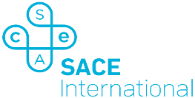

About the SACE International Program
The SACE is the official senior secondary qualification of the Government of South Australia. It is typically delivered in a students' final two years of schooling.

The SACE shifts the focus from memorising for exams to learning the research and thinking skills to solve problems in the real world. Our graduates can successfully deal with challenges at university, at work and in their communities. The SACE is a flexible program that is tailored for each student, putting them on the pathway to success.

All Australian universities and major global universities accept the qualification. Thousands of our graduates are studying at top universities around the world.

